Instructor |  |  | Course Date(s)
Course Title |  |  | County
Students (Complete) |  |  | Students (Incomplete)
Student Hours (Complete) |  |  | Student Hours (Incomplete)
Total Student Hours (Complete +Incomplete)
Was the Course Cancelled? (Circle One) |  | YES |  | NO
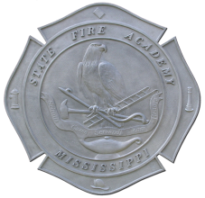

Mississippi State Fire Academy

Instructor Course Narrative

Regional and Interdepartmental Training

Course Narrative:
____________________________________________________________________________________________________________________________________________________________________________________________________________________________________________________________________________________________________________________________________________________________________________________________________________________________________________________________________________________________________________________________________________________________

Complete and Initial Before Returning:
Typed Roll Sheet(s) including: Complete/Incomplete, Hours of credit for each student
Original Roll Sheet(s)
Student Evaluations

