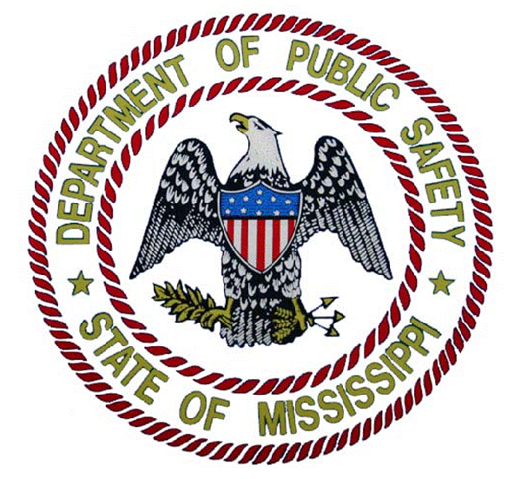

State of Mississippi
Department of Public Safety
PHIL BRYANT OFFICE OF HOMELAND SECURITY MARSHALL FISHER
GOVERNOR COMMISSIONER

DATE: June 1, 2017
FROM: Marsha Manuel, Grants Director
RE: 2017 FUNDING OPPORTUNITY ANNOUNCEMENT AND STAKEHOLDER INPUT

The Mississippi Office of Homeland Security is announcing the availability of the FY 2017 State Homeland Security Funding Opportunity as well as conducting a State-wide Threat and Hazards review (your input will be utilized to develop Mississippi’s State Homeland Security Grant Program Funding Request, State Threat and Hazard identification and Risk Assessment, as well as the annual State Preparedness Report).

In your funding request/stakeholder response please provide the following:
1. One brief paragraph describing each of your jurisdictions top three threats.
2. One brief paragraph describing each of your jurisdictions top three hazards.
3. One to three brief paragraph(s) describing any capability gap which inhibits your jurisdiction’s ability to respond to the threats and hazards you have identified. Explain how you determined your capability gaps (i.e. a response to a real life event, an exercise, a training event). Please address how utilization of existing state-wide assets (Task Forces, Force Protection Units, bomb teams, etc) may/may not mitigate the threats and hazards you have identified.
4. Provide a Budget Detail Worksheet outlining the piece(s) of equipment, cost per item(s), number of item(s), and a grand total of the amount that you are requesting.
5. Acknowledge and provide a brief description of having an adequate property management system.
6. Complete the enclosed NIMS Compliance form.

**Verify equipment eligibility: Go to “Google” and type in “DHS Authorized Equipment List”

**This document serves as your request for FY 2017 MOHS grant funding and must be completed properly and returned by the due date stated for consideration of grant funding from MOHS. Please submit your funding request/stakeholder response to Mississippi Office of Homeland Security (Attn. Mrs. Marsha Manuel, Grants Director, P.O. Box 958 Jackson, MS 39205) no later than August 31, 2017. No electronic submissions will be accepted.
Your input is vital to help us compile and communicate a comprehensive picture of the threats, hazards and capability gaps that exist within our State. Your participation is greatly appreciated.

2017 NIMS COMPLIANCE FORM

To: The Mississippi Office of Homeland Security
1230 Raymond Rd.
Jackson, MS 39204

Attn: Office of Grants
Homeland Security Directive 5 mandates governments shall implement a consistent system for working together during incidents or events. The National Incident Management System (NIMS) has been designed to provide effective incident and event management. NIMSCAST has been designed for recording said NIMS compliance. Mississippi under Executive Order #932 established NIMS as the standard for incident management within the state. Department of Homeland Security/Federal Emergency Management Agency guidance provides that accepting grant funding is conditional on compliance with NIMS. This jurisdiction attests that we continue to strive toward NIMS compliance as provided under federal and state NIMS guidance. This jurisdiction also attests that compliance shall be correctly recorded within the NIMSCAST tool. This jurisdiction understands receiving and/or using Homeland Security grant funds remains conditional upon successful participation in respect to NIMS compliance and reporting. Non-compliance of NIMS can result in Homeland Security dollars being withheld from or drawn back from our jurisdiction because of ineffective NIMS support and participation.
This understood and attested to:
Signed: __________________________________________
Printed name: ____________________________________
Jurisdiction represented: ___________________________
Dated: _________________________
Witness sign: ___________________________________
Printed name: __________________________________

