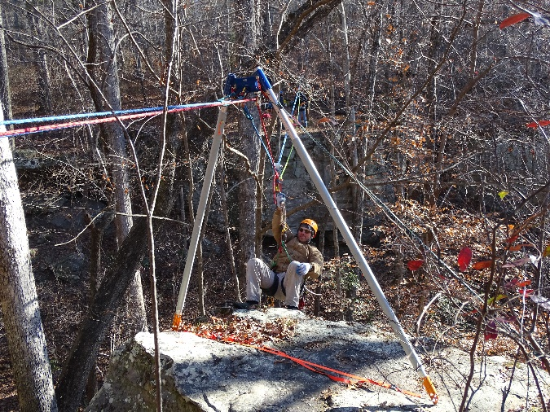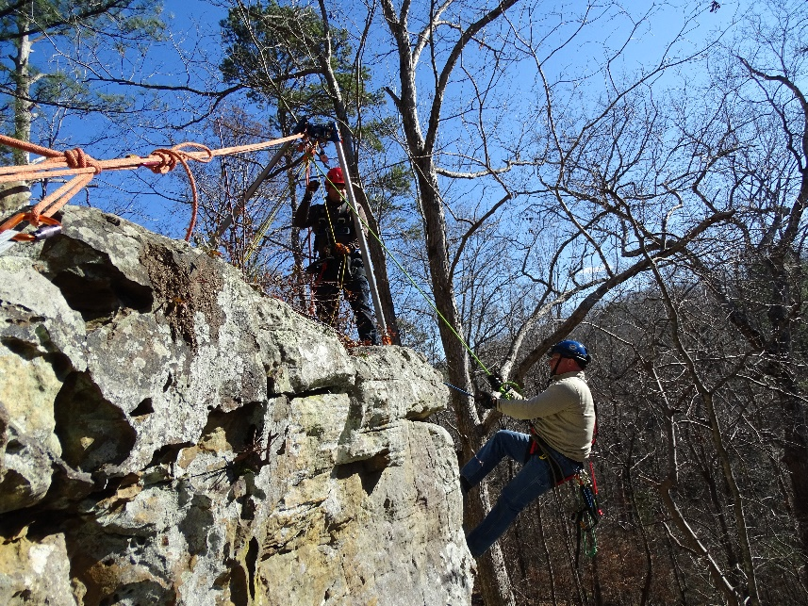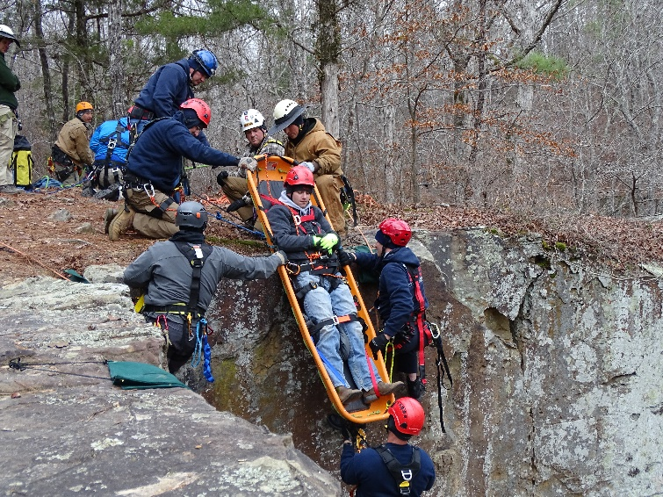

Tishomingo State Park

Advanced Rope Rescue Workshop- Wilderness

This advanced rescue workshop, brought to you by the Mississippi State Fire Academy, will take students out of their customary urban / industrial setting and to the pristine cliffs of northeast Mississippi. The course will build on skills acquired in NFPA Rope Rescue Level 2 and apply them to the wilderness environment.

Topics include: artificial anchors, artificial high directional(AHDs), litter tending, horizontal rope systems, and an emphasis on individual movement on rope. The course will take place Friday morning until Sunday lunch (24 hours total). The enrollment is limited to 12 attendees. Students will be required to perform a skills demonstration of: ascending with change-overs, knots, and MAs, prior to participating in the workshop.

**Prerequisites: Rope Rescue Level 2 (2010 or later) & Skills Demonstration**

**Students are expected to bring: helmet, harness, gloves, climbing system,**

**Cost: $60**

**Contact: Hayes Nix** [**hnix@msfa.state.ms.us**](mailto:hnix@msfa.state.ms.us) **601-420-1740**

**Lodging & Meals: Participants responsible for meals and lodging. Camping and Cabins Available.**

Tishomingo State Park

105 CR 90 Tishomingo, MS 38873

Friday Nov 30 – Sunday Dec. 2, 2018