Saturday  June 26th  8 a.m. – 12 p.m. SEAFC Board meeting  8 a.m. – 4 p.m. Exhibit Hall Open  TBD MFFA Educational Sessions  TBD MFFA Business Meeting  2:15 – 2:30 p.m. Break  Tuesday  June 22nd  1 P.M. -5 P.M. SEAFC Board Meeting  1:30 P.M.- 5 P.M. Registration open  1:00 P.M.- 5 P.M. ISO Pre Conference  Wednesday  June 23RD  8 a.m –4 p.m. Registration  8 a.m. –11:30 a.m. ISO Pre-Conference  8 a.m –12 p.m. SEAFC Board Meeting  9:30 – 10 a.m. Break  12 P.M. – 1 p.m. Lunch (On Your OWN)  1 P. M.– 2:15 p.m. Opening Ceremony Memorial Service  2:15 – 2:30 p.m. Break  2:30 – 4 p.m. Pete Blank, “5 Ways to Add Disney Magic to your Fire Department”  4 – 4:15 p.m. Break  4:15 - 5 p.m. SEAFC Business Meeting | 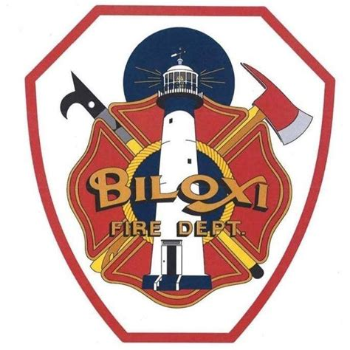  tHURSDAY  JUNE 24TH  8 a.m. – 4 p.m. Registration  8 – 9:30 a.m. Pete Blanc – “Pick Up the Roach! Why Great Fire Chiefs do the Little Things”  9:30 – 10:30 a.m. BreAK  10:30 a.m. – 12 p.m. Jeff Dill – “Saving Those Who Save Others”  12 p.m. – 5 p.m. Exhibit Hall Open  12 – 1 p.m. Lunch (Provided)  12 – 3:00 p.m. President’s Forum  1:15 – 3:15 p.m. . Robert R. Rielage – “Firefighting Electric and Alternative Fueled Vehicles – A Jigsaw Puzzle for Us to Solve” Presented by Lexipol and United Badges Insurance  3:15 – 3:30 Break  3:30 – 5:00 Lydia McCary – “Breaking the Cycle – The Community Response”  5:00 – 6 p.m MFCA Board Meeting  6 p.m. – Until Night at Museum and Block Party | SEAFC  93rd Annual Leadership  Conference  Mississippi Fire Chiefs  Joint Conference  - June 23rd-26th, 2021  - IP Casino & Resort  - Biloxi,Mississippi  Friday  june 25th  8 – 10 a.m. Registration  9 a.m. – 5 p.m. MFFA All-Day Event  9 a.m. – 5 P.m. Exhibit Hall Open  8 – 9:30 a.m. Mark Nugent – “Incident After Action Review”  MFCA Business Session Immediately Following  9:30 – 10:30 a.m. Break  10:30 – 12 p.m. Brian Marcos – “Overhauling the Performance Appraisal”  11:45 – 1 p.m. Lunch (provided)  1:15 – 2:15 p.m. Gary McCarraher – “FirstNet on the Move  2:15 – 2:30 p.m. Break  2:30 – 3:30 p.m. Crosby Grindle – “Save Time and Money with Cooperative Purchasing”  6:00 – 6:45 p.m. Reception  6:45 – 8:30 p.m. President’s Dinner & Award Banquet

